PROJECT OVERVIEW
Title of Project
Online Electronic Product Management System.

Project Members:
1: Nikam Rushikesh (Project Manager)
2: Ambare Sonali
3: Mugale Pallavi
4: Chavan Srushti
5: Deshmukh Sneha

Project Guide: Mr.Pankaj Patil Sir

Objective of Project:
An online management system is the mechanism within a organization that is used for efficient management of the movement and storage of products and related flow of information.
Tools/Platform,Hardware &Software Requirement
Specifications
Platform:Windows XP
Front End:C#.Net
Back End:SQL

Hardware Requirement
Pentium III, 700 MHz,40 GB HDD,256 MB RAM,A CD Writer/Reader

Software Requirement
VB 4.5
SQL
MS Windows XP
C#.Net

Introduction to VB 4.5:

Visual Basic was designed to be easily learned and used by beginner programmers. Thelanguage not only allows programmers to create simple GUI applications, but can also developcomplex also developcomplex applications. Programming in VB is a combination of visually arranging components or controls on a form ,specifying attributes and actions of these components, and writing addtional lines of code for more functionality. Since default attributes and actions are defined for the components, a simple program can be created without the programmer having to write many lines of code. Performance problems were experienced by earlier versions, but with faster computers and native code compilation this has become less of an issue.

Analysis:
Online management system becoming an essential to efficientlymanage inventories in computer age. Electronic product Management System is a workable application for retail store inventory and accounts management. It keeps a list STOCKS and products at a store and can do operations on them. The most important operation is a "PURCHASE", transactions and billing details and stock purchasing details involved on it. Why We Want to Hold Inventories
•Improve customer service
•Reduce certain costs such as
•Ordering costs
•Stock out costs
•Acquisition costs
•Start-up quality costs
• Contribute to the efficient and effective operation of the production system
Data Dictionary
➢ LOGIN_MST
➢CUSTOMER_MST
➢ PRODUCT_MST
➢ORDER_MST
➢ FEEDBACK_MST
➢USER_FEEDBACK

ER-DIAGRAM
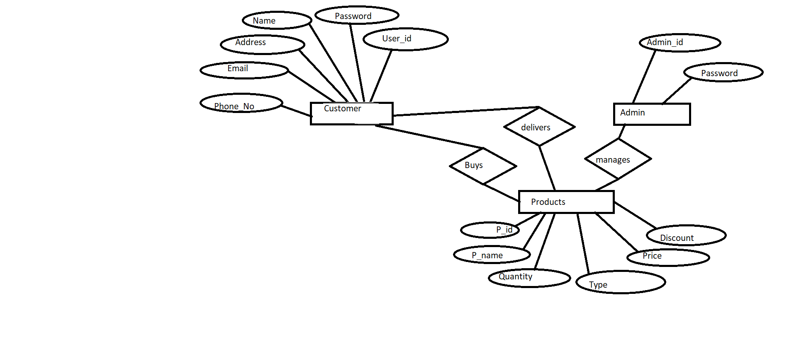

There Are Tow Process Work By System:

1.ADMIN
2.CUSTOMER
Admin Process
➢Admin First Login And Has The Right To Handle The Entire System.
➢ Admin Can Add, Update And Delete Products.
➢Admin Can Check Order Details.
➢Admin Can View FeedBack.
➢Admin Can Generate Report.
Customer Process
➢ User View The Product Details.
➢ User can Get The Products Configuration.
➢ User Now Give The FeedBack.
➢ User can Calculate The Tiles.
➢ User Need To Login.
➢ If A User Is Not Register Then He Has To First Get
Register.
➢ If He Is A Already User Provide User Name Password
And Get Login.
➢ User can now give order.
➢ User can now see the status of the order given.

Process Algorithm
➢ Step1: - Admin Login The Application If User
Name And Password Is Correct Then Go to Step 2
Else If Not Then Re enter UserName And Password.
➢ Step2:-Add, Update and Delete Products,
Check Order Details, View FeedBack.
➢ Step3:-Create Report Of Order.
➢ Step4:-Stop

Customer Process
➢Step1:-User View The Product Details And Get
The Product Configuration.
➢Step2:- User Can View The FeedBack.
➢Step3:-User Will Calculate Tiles.
➢Step4:-To Give Order User need To Login.
➢Step5:-If A User Is New User Then It Has To Be
Register It Self.
➢Step6:-Give The UserName And Password To
Login.
➢Step7:-User Can Give Order.
➢Step8:-User Can View Order Status .
➢Step9:-Stop.

Testing
We have use following method for testing the system.
➢Specification Testing:
- The specification testing is what program does in some various
condition is.
- we check this system to give wrong userneme,password,wrong
data then system display message for input correct data.
➢Code Testing:
- The code testing is examining the logic of program.
- we have testing all path of program, path means to specific
combination of condition that handle by program.
- when the any User give order that check correct id,password &
User number etc.

Unit Testing:
- unit testing is focused on verifying small portion of functionality.
Unit testing is important part where each module and process of
application is to be test by possible input sets and desired output.
- we have check different type of modules like admin module, User
module etc.

POST IMPLEMENTATION REVIEW
.After the system is implemented and conversation is
complete, a review of system is usually conducted by users,
this is called post implementation.
.The most fundamental concern post implementation review is
determining whether the system has met its objectives; that is
analyst want to know if the performance level of user has
improved and if the system is producing the result intended. If
neither is happening, one may question whether the system can
be considered successful.
➢ In future Payment Gateway can be use for the transaction
related to the Order of the Products.
➢ We will think to make this web application more interactive in
design.
➢ In future we can try to implement the advertisement also can
be implemented in the web page.

Future Enhancement
In future Payment Gateway can be use for the transaction
related to the Order of the Products.
➢ We will think to make this web application more interactive in
design.
➢ In future we can try to implement the advertisement also can
be implemented in the web page.

BIBLIOGRAPHY

NAME AUTHOR
> ASP. NET UNLEASED Stephan Wither
>Professional ASP.NET WROX Publication
>ASP.NET Black Book Dreamtech Publication

We had been used the reference of the following websites.
I. http://www.asiangranito.com
II. http://www.w3schools.com

THANK YOU !

